

**Software Design Description**

**Hanoi, April 12th, 20201**

**Table of Contents**

**Chapter 4: Software Design Description** 2

**4****.1. System Architecture Design**

***4.2******.1. Choice of System Architecture***

***4.2******.2. Discussion of Alternative Designs***

***4.2******.3. Description of System Interface***

**4****.3. Component Diagram** 2

**4****.4. Detailed Description of Components** 3

***4***[***.4.1. CRC Cards (Class-Responsibility-Collaborators)*** *3*](https://docs.google.com/document/d/1gRhesEx9OtIXu6NM8EbwjelwWmyH6FQW/edit#heading=h.17dp8vu)

***4.4.1.n. Component-n***

***4.4.1.n.1. Class Diagram***

***4.4.2.n.2. Class Diagram Explanation***

***4.4.3.n.3. Algorithms of important methods in each class, specified in pseudo code or by Flow-Chart***

**4****.5. Sequence Diagram** 3

**4****.6. User Interface Design** 5

***4******.6.1. Description of the User Interface*** 5

***4******.6.12.1 Screen Images*** 6

***1.6.12.2*** ***Objects and Actions*** *7*

**4.7. Database Design or Data Structures 5**

**4****.8. Other material (if any)**

# **Detailed Description of Components**

## **4.1. System Architecture Design**



*Figure 4.1 – System Architecture Design*

## 

## **4.1.0 Software Architecture Design**

## 

*Figure 4.2 – Software Architecture Design*

## ***4.1.1. Choice of System Architecture***



*Figure 4.2 – Model-View-Controller pattern*

The Model-View-Controller (MVC) structure, which is the standard software development approach offered by most of the popular web frameworks, is clearly a layered architecture. Just above the database is the model layer, which often contains business logic and information about the types of data in the database. At the top is the view layer, which is often CSS, JavaScript, and HTML with dynamic embedded code. In the middle, you have the controller, which has various rules and methods for transforming the data moving between the view and the model.

## ***4.1.2. Description of System Interface***

***4.1.2.1. Database management system***

## 

*Database management system*

Database management system is a software which is used to manage the database. For example: SQL Server, MySQL, Oracle, etc are a very popular commercial database which is used in different applications. DBMS provides an interface to perform various operations like database creation, storing data in it, updating data, creating a table in the database and a lot more. It provides protection and security to the database. In the case of multiple users, it also maintains data consistency.

***4.1.2.2. Web browser***

## 

*Browsers*

A web browser (commonly referred to as a browser) is a software application for accessing information on the World Wide Web. When a user requests a web page from a particular website, the web browser retrieves the necessary content from a web server and then displays the page on the user's device. A web browser is not the same thing as a search engine, though the two are often confused. For a user, a search engine is just a website that provides links to other websites. However, to connect to a website's server and display its web pages, a user must have a web browser installed. Web browsers are used on a range of devices, including desktops, laptops, tablets, and smartphones. . In 2019, an estimated 4.3 billion people used a browser.

***4.1.2.3. Google Authenticator***

**

*Google Authenticator*

Google Authenticator is a software-based authenticator by Google that implements two-step verification services using the Time-based One-time Password Algorithm and HMAC-based One-time Password[1] algorithm , for authenticating users of software applications.

When logging into a site supporting Authenticator (including Google services) or using Authenticator-supporting third-party applications such as password managers or file hosting services, Authenticator generates a six- to eight-digit one-time password which users must enter in addition to their usual login details.

***4.1.2.3. Simple Mail Transfer Protocol (SMTP)***



*Simple Mail Transfer Protocol*

The Simple Mail Transfer Protocol (SMTP) is a communication protocol for electronic mail transmission. As an Internet standard, SMTP was first defined in 1982 by RFC[2] 821, and updated in 2008 by RFC 5321 to Extended SMTP additions, which is the protocol variety in widespread use today. Mail servers and other message transfer agents use SMTP to send and receive mail messages. SMTP servers commonly use the Transmission Control Protocol on port number 25.

User-level email clients typically use SMTP only for sending messages to a mail server for relaying, and typically submit outgoing email to the mail server on port 587 or 465 as per RFC 8314. For retrieving messages, IMAP[3] and POP3[4] are standard, but proprietary servers also often implement proprietary protocols, e.g.

**4.2.**  **Component Diagram**



## **4.3. Detailed Description of Component**

***4.3.1. View***



## **4.4. Class Diagram**

***4.4.1. Class diagram***

***4.4.1.1. Post Class Diagram***



***4.4.1.2. Account Class Diagram***



***4.4.1.3. Profile Class Diagram***



***4.4.1.4. Notification Class Diagram***



***4.4.1.5. Message Class Diagram***



***4.4.2. Models***

***4.4.2.1 Account***



**Class specification**

|  |  |  |  |
| --- | --- | --- | --- |
| **NO** | **Attribute** | **Type** | **Description** |
| 01 | id | int | ID of account |
| 02 | username | string | User Name of account |
| 03 | password | string | Password of account |
| 04 | isActive | boolean | Status active of account |
| 05 | isBlock | boolean | Status block of account |

|  |  |  |
| --- | --- | --- |
| **NO** | **Method** | **Description** |
| 01 | Account(int iD, string userName, string password, bool isActive, bool isBlock) | Default constructor |
| 02 | Account(DataRow row) | Another constructor |

***4.4.2.2 AccountLog***



**Class specification**

|  |  |  |  |
| --- | --- | --- | --- |
| **NO** | **Attribute** | **Type** | **Description** |
| 01 | id | int | ID of log |
| 02 | accountID | int | ID of account log |
| 03 | beforeBalance | double | Balance of account before transaction |
| 04 | afterBalance | double | Balance of account after transaction |
| 05 | transactionID | int | ID of transacation |

|  |  |  |
| --- | --- | --- |
| **NO** | **Method** | **Description** |
| 01 | AccountLog(int iD, int accountID, double beforeBalance, double afterBalance, int transactionID) | Default constructor |
| 02 | AccountLog(DataRow row) | Another constructor |

***4.4.2.3 Comment***



**Class specification**

|  |  |  |  |
| --- | --- | --- | --- |
| **NO** | **Attribute** | **Type** | **Description** |
| 01 | id | int | Id of comment |
| 02 | accountID | int | Id of account comment |
| 03 | postID | int | Id of the post |
| 04 | content | string | Content of the comment |
| 05 | time | DateTime | Time comment is created |

|  |  |  |
| --- | --- | --- |
| **NO** | **Method** | **Description** |
| 01 | Comment(int id, int accountID, int postID, string content, Datetime time) | Default constructor |
| 02 | Comment(DataRow row) | Another constructor |

***4.5.2.4 Feedback***

**Class specification****

|  |  |  |  |
| --- | --- | --- | --- |
| **NO** | **Attribute** | **Type** | **Description** |
| 01 | id | int | Id of the feedback |
| 02 | title | string | Title of the feedback |
| 03 | content | string | Content of the feedback |
| 04 | userFeedbackId | id | Id of the user have send feedback |
| 05 | lastUpdated | string | The final date update the feedback |
| 06 | status | int | Status of Feedback :   * Status = 1 : Resolved * Status = 2 : Unresolved * Status = 3 : Rejected |

|  |  |  |
| --- | --- | --- |
| **NO** | **Method** | **Description** |
| 01 | Feedback(int id,string title, string content, int userFeedbackId, string lastUpdated, int status) | Default constructor |
| 02 | Feedback(DataRow row) | Another constructor |

***4.4.2.5 Follow***



**Class specification**

|  |  |  |  |
| --- | --- | --- | --- |
| **NO** | **Attribute** | **Type** | **Description** |
| 01 | relationId | int | Relation of the Following :   * Relation = 1 : Follow * Relation = 2 : Block |
| 02 | followerId | int | Id of the user follow |
| 03 | userGetFollowId | int | Id of the user is followed |

|  |  |  |
| --- | --- | --- |
| **NO** | **Method** | **Description** |
| 01 | Follow() | Default constructor |
| 02 | Follow(int relationId, int followerId, int userGetFollowId) | Another constructor |

***4.4.2.6 Image***



**Class specification**

|  |  |  |  |
| --- | --- | --- | --- |
| **NO** | **Attribute** | **Type** | **Description** |
| 01 | id | int | Id of the image |
| 02 | postId | int | Id of the post contain the image |
| 03 | url | string | The path to the image file |

|  |  |  |
| --- | --- | --- |
| **NO** | **Method** | **Description** |
| 01 | Image(int postID, string url) | Default constructor |
| 02 | Image(DataRow row) | Another constructor |

***4.4.2.7 Infor***



**Class specification**

|  |  |  |  |
| --- | --- | --- | --- |
| **NO** | **Attribute** | **Type** | **Description** |
| 01 | id | int | Id of the Infor |
| 02 | accountID | int | Id of the account have the infor |
| 03 | height | double | Height of the person |
| 04 | weight | double | Weight of the person |
| 05 | bustSize | double | The size of the butt |
| 06 | waistSize | double | The size of the waist |
| 07 | hipSize | double | Size of the hip |
| 08 | name | string | Name of the Infor |

***4.4.2.8 Message***



**Class specification**

|  |  |  |  |
| --- | --- | --- | --- |
| **NO** | **Attribute** | **Type** | **Description** |
| 01 | id | int | Id of the message |
| 02 | fromAccountId | int | Id of sender |
| 03 | toAccountId | int | Id of the receiver |
| 04 | content | string | Content of the message |
| 05 | senderDeleted | boolean | Status of the message on sender :   * Status = 0 : UnDeleted * Status = 1 : Deleted |
| 06 | receiverDeleted | boolean | Status of the message on receiver:   * Status = 0 : Undeleted * Status = 1 : Deleted |
| 07 | isRead | boolean | Status of the message on receiver is read:   * Relation = 0 : Unread * Relation = 1 : Read |
| 08 | conversationId | int | Id of the conversation |
| 09 | time | DateTime | Time of the message |

|  |  |  |
| --- | --- | --- |
| **NO** | **Method** | **Description** |
| 01 | Message(int iD, int fromAccountId, int toAccountId, string content,boolean senderDeleted, boolean receiverDeleted, boolean isRead,int conversationId, DateTime, time) | Default constructor |
| 02 | Message(DataRow row) | Another constructor |

**4.5.3. DAO**

***4.5.3.1 AccountDAO***



**Class specification**

|  |  |  |
| --- | --- | --- |
| **NO** | **Method** | **Description** |
| 01 | AddAccount(AccountViewModelIn accountViewModel) | Create an account for users |
| 02 | AddNewStaff(AccountViewModelIn) | Create a new account for staff manager |
| 03 | GetUserWithRoleByUserName(string username) | Get information of users with their username |
| 04 | GetUserWithRoleByEmail(string username) | Get information of users with their Email |
| 05 | GetUserWithRoleByPhone(string username) | Get information of users with their Phone |
| 06 | UpdateUserPassword(string username, string newPassword) | Change user password |
| 07 | GetAllUser() | Get all user in system |
| 08 | GetUserById(int id) | Get an user’s account and profile by his/her ID |
| 09 | GetUserDetailById(int id) | Get an user’s profile and statistics |
| 10 | BanUser(int accountId) | Ban an user |
| 11 | UnbanUser(int accountId) | Unban an user |

***4.5.3.2. ProfileDAO***



**Class specification**

|  |  |  |
| --- | --- | --- |
| **NO** | **Method** | **Description** |
| 01 | GetProfileModelByAccountID (int accountId) | Get an custom profile by account id |
| 02 | UpdateProfileByAccountID(int accountId, ProfileViewModelIn newProfile) | Update an profile by account id |
| 03 | UpdateAvatarByAccountID(int accountId, ProfileViewModelIn newProfile) | Update an user’s profile avatar by account id |
| 04 | GetProfileByAccountID(int id) | Get user’s profile by account id |
| 05 | GetProfileByEmail(string email) | Get user’s profile by user’s email |
| 06 | GetProfileByPhone(string phone) | Get user’s profile by user’s phone |
| 07 | getPeopleFollowByAccountId(int accountId) | Get people follow an account by account id |

***4.5.3.3 CareerDao***

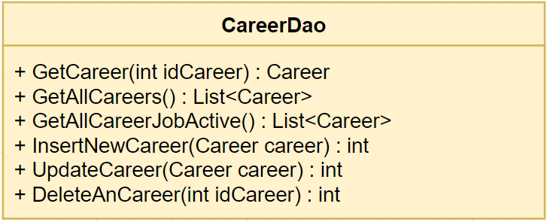

**Class specification**

|  |  |  |
| --- | --- | --- |
| **NO** | **Method** | **Description** |
| 01 | GetCareer(int idCareer) | Get information of a career |
| 02 | GetAllCareers() | Get all career in system |
| 03 | GetAllCareerJobActive() | Get all career of jobs which are active |
| 04 | InsertNewCareer(Career career) | Create a new career into system |
| 05 | UpdateCareer(Career career) | Update a career in system |
| 06 | DeleteAnCareer(int idCareer) | Delete a career in system |

***4.5.3.4 CareerDao***

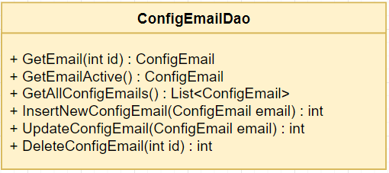

**Class specification**

|  |  |  |
| --- | --- | --- |
| **NO** | **Method** | **Description** |
| 01 | GetEmail(int id) | Get an email config in system |
| 02 | GetEmailActive() | Get an email config is active in system which is used to send mail to candidate |
| 03 | GetAllConfigEmails() | Get all emails config in system |
| 04 | InsertNewConfigEmail(ConfigEmail email) | Create an new email config into system |
| 05 | UpdateConfigEmail(ConfigEmail email) | Edit an email config in system |
| 06 | DeleteConfigEmail(int id) | Delete an email config in system |

***4.5.3.5 CvDao***

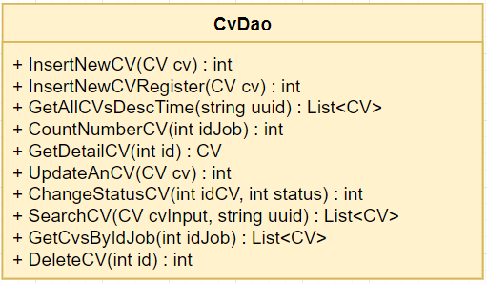

**Class specification**

|  |  |  |
| --- | --- | --- |
| **NO** | **Method** | **Description** |
| 01 | InsertNewCV(CV cv) | Create a new CV when candidate apply job |
| 02 | InsertNewCVRegister(CV cv) | Create a new CV when candidate register potential candidate |
| 03 | GetAllCVsDescTime(string uuid) | Get all CV are managed by login account |
| 04 | CountNumberCV(int idJob) | Count number of CVs were apply for a job |
| 05 | GetDetailCV(int id) | Get detail of a CV |
| 06 | UpdateAnCV(CV cv) | Edit an CV |
| 07 | ChangeStatusCV(int idCV, int status) | Change status of CV   * Status = 1 : Mới * Status = 2 : Đã xem * Status = 3 : Cân nhắc * Status = 4 : Chấp nhận * Else : Từ chối |
| 08 | SearchCV(CV cvInput, string uuid) | Search CV base on information input |
| 09 | GetCvsByIdJob(int idJob, string uuid) | Get all CVs were applied for a job |
| 10 | DeleteCV(int id) | Delete a CV in system |

***4.5.3.6 EmailStatusDao***

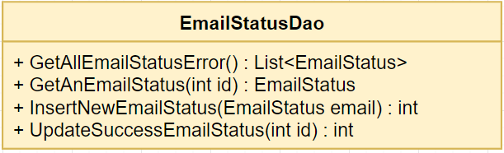

**Class specification**

|  |  |  |
| --- | --- | --- |
| **NO** | **Method** | **Description** |
| 01 | GetAllEmailStatusError() | Get all emails which were error send to candidate |
| 02 | GetAnEmailStatus(int id) | Get an email was send in system |
| 03 | InsertNewEmailStatus(EmailStatus email) | Insert a new email when system send to candidate |
| 04 | UpdateSuccessEmailStatus(int id) | Update email was resend success in system |

***4.5.3.7 JobsDao***

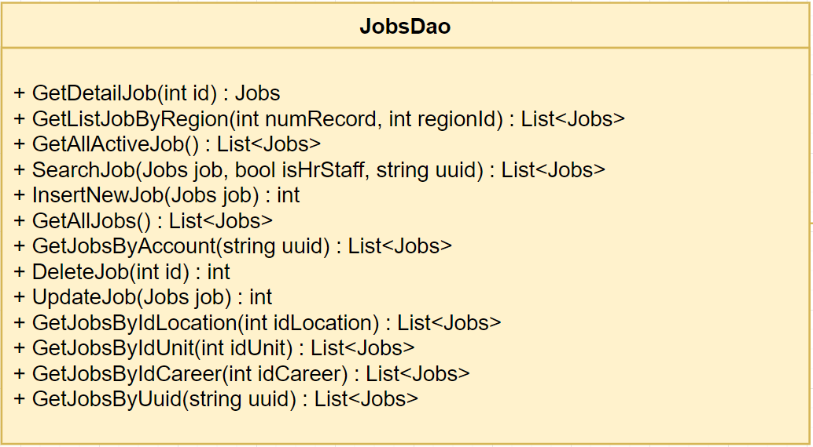

**Class specification**

|  |  |  |
| --- | --- | --- |
| **NO** | **Method** | **Description** |
| 01 | GetDetailJob(int id) | Get detail information of job |
| 02 | GetListJobByRegion(int numRecord, int regionId) | Get list job by a region |
| 03 | GetAllActiveJob() | Get all jobs is active in system |
| 04 | SearchJob(Jobs job, bool isHrStaff, string uuid) | Candidates search jobs with conditions of input, but HR staff just search jobs which are managed by HR staff and based on location. |
| 05 | InsertNewJob(Jobs job) | Create a new job into system |
| 06 | GetAllJobs() | Get all jobs in system |
| 07 | GetJobsByAccount(string uuid) | Get all job were created and managed by login account |
| 08 | GetJobsByUuid(string uuid) | Get all jobs were created by login account |
| 09 | DeleteJob(int id) | Delete a job in system |
| 10 | UpdateJob(Jobs job) | Edit a job in system |
| 11 | GetJobsByIdLocation(int idLocation) | Get all job of a location |
| 12 | GetJobsByIdUnit(int idUnit) | Get all jobs of an unit |
| 13 | GetJobsByIdCareer(int idCareer) | Get all jobs of a career |

***4.5.3.8 LocationDao***

***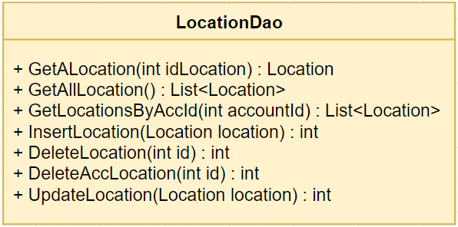* Class specification**

|  |  |  |
| --- | --- | --- |
| **NO** | **Method** | **Description** |
| 01 | GetALocation(int idLocation) | Get information of a location in system |
| 02 | GetAllLocation() | Get all locations in system |
| 03 | GetLocationsByAccId(int accountId) | Get all locations are managed by an account |
| 04 | InsertLocation(Location location) | Create a location into system |
| 05 | DeleteLocation(int id) | Delete a location in system |
| 06 | DeleteAccLocation(int id) | Delete all account’s location management right |
| 07 | UpdateLocation(Location location) | Edit a location in system |

***4.5.3.9 LogActionDao***

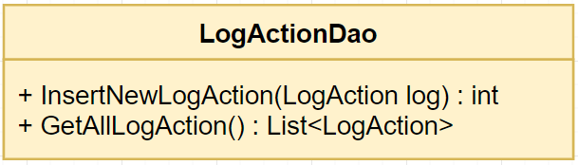

**Class specification**

|  |  |  |
| --- | --- | --- |
| **NO** | **Method** | **Description** |
| 01 | InsertNewLogAction(LogAction log) | Create a new log action of an account |
| 02 | GetAllLogAction() | Get all logs were created in system |

***4.5.3.10 PriorityDao***

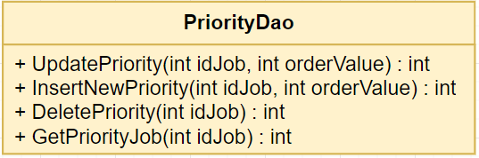

**Class specification**

|  |  |  |
| --- | --- | --- |
| **NO** | **Method** | **Description** |
| 01 | UpdatePriority(int idJob, int orderValue) | Update order value priority of a job |
| 02 | InsertNewPriority(int idJob, int orderValue) | Create a order value priority of a job |
| 03 | DeletePriority(int idJob) | Delete order value priority of a job |
| 04 | GetPriorityJob(int idJob) | Get order value priority of a job |

***4.5.3.11 QuizDao***

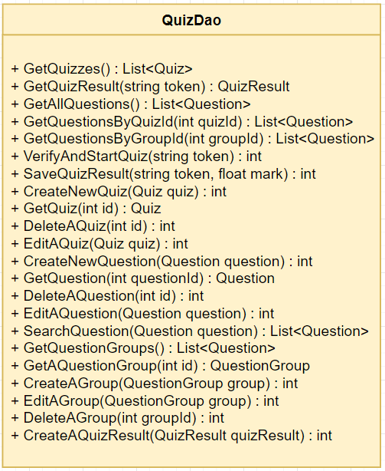

**Class specification**

|  |  |  |
| --- | --- | --- |
| **NO** | **Method** | **Description** |
| 01 | getQuizzes() | Get all quizzes in system |
| 02 | GetQuizResult(string token) | Get result of a quiz |
| 03 | GetAllQuestions() | Get all questions in system |
| 04 | GetQuestionsByQuizId(int quizId) | Get all questions of a quiz |
| 05 | GetQuestionsByGroupId(int groupId) | Get all questions of a group question |
| 06 | VerifyAndStartQuiz(string token) | Verify a result of a quiz to start this quiz |
| 07 | SaveQuizResult(string token, float mark) | Update result of quiz after finish |
| 08 | CreateAQuizResult(QuizResult quizResult) | Create result of a quiz |
| 09 | CreateNewQuiz(Quiz quiz) | Create a new quiz in system |
| 10 | GetQuiz(int id) | Get information of a quiz in system |
| 11 | DeleteAQuiz(int id) | Delete a quiz in system |
| 12 | EditAQuiz(Quiz quiz) | Edit a quiz in system |
| 13 | CreateNewQuestion(Question question) | Create a new question in system |
| 14 | GetQuestion(int questionId) | Get information of a question in system |
| 15 | DeleteAQuestion(int id) | Delete a question in system |
| 16 | EditAQuestion(Question question) | Edit a question in system |
| 17 | SearchQuestion(Question question) | Search question with input condition |
| 18 | GetQuestionGroups() | Get all question groups in system (include question in this group) |
| 19 | GetAQuestionGroup(int id) | Get information of a question group in system (include question in this group) |
| 20 | CreateAGroup(QuestionGroup group) | Create a group question in system |
| 21 | EditAGroup(QuestionGroup group) | Edit a group question in system |
| 22 | DeleteAGroup(int groupId) | Delete a group question in system |

***4.5.3.12 RegionDao***

**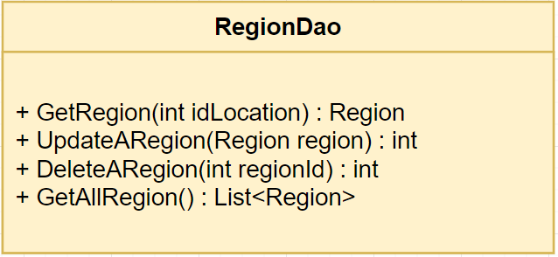  
 Class specification**

|  |  |  |
| --- | --- | --- |
| **NO** | **Method** | **Description** |
| 01 | GetRegion(int idLocation) | Get region of a location |
| 02 | UpdateARegion(Region region) | Edit a region in system |
| 03 | DeleteARegion(int regionId) | Delete a region in system |
| 04 | GetAllRegion() | Get all regions in system |

***4.5.3.13 RolesDao***

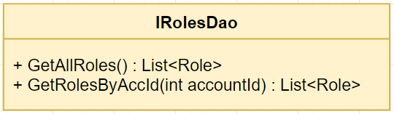

**Class specification**

|  |  |  |
| --- | --- | --- |
| **NO** | **Method** | **Description** |
| 01 | GetAllRoles() | Get all roles in system |
| 02 | GetRolesByAccId(int accountId) | Get all roles of an account in system |

***4.5.3.14 UnitDao***

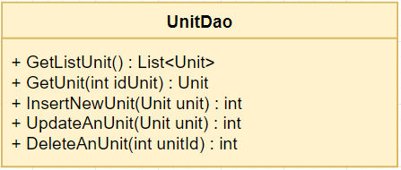

**Class specification**

|  |  |  |
| --- | --- | --- |
| **NO** | **Method** | **Description** |
| 01 | GetListUnit() | Get all units in system |
| 02 | GetUnit(int idUnit) | Get information of an unit in system |
| 03 | InsertNewUnit(Unit unit) | Create an new unit in system |
| 04 | UpdateAnUnit(Unit unit) | Edit an unit in system |
| 05 | DeleteAnUnit(int? unitId) | Delete an unit in system |

***4.5.3.15 ViewsDao***

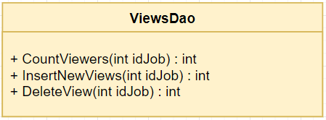

**Class specification**

|  |  |  |
| --- | --- | --- |
| **NO** | **Method** | **Description** |
| 01 | CountViewers(int idJob) | Count number of viewer of a job |
| 02 | InsertNewViews(int idJob) | Insert of new view of a job |
| 03 | DeleteView(int idJob) | Delete all view of a job |

**4.5.4 Controller**

***4.5.4.1 BaseController***



**Class specification**

|  |  |  |
| --- | --- | --- |
| **NO** | **Method** | **Description** |
| 01 | BaseController() | Default constructor |
| 02 | GetUuidFromSession() | Get uuid of login account from session |
| 03 | IsRole(int roleId) | Check an account has role or not |
| 04 | IsSupperAdmin() | Check an account is Super Admin or not |
| 05 | IsHRStaff() | Check an account is HR Staff or not |
| 07 | CheckDuplicateEmail(string email) | Check email of an account is exist or not |

## 

## ***4.5.4.2 AccountController***



**Class specification**

|  |  |  |
| --- | --- | --- |
| **NO** | **Method** | **Description** |
| 01 | AccountController | Default constructor |
| 02 | Index() | If login account is Admin, then redirect to Admin page  If login account is HR staff, then redirect to HR staff page  If not login, redirect to login page |
| 03 | RequestAsync(string token) | Verify token with google |
| 04 | Logout() | Logout account from system |
| 05 | Login() | Redirect to login page |
| 07 | Login(string token) | Login account into system |

## 

## ***4.5.4.3 AdminController***

## 

**Class specification**

|  |  |  |
| --- | --- | --- |
| **NO** | **Method** | **Description** |
| 01 | AdminController() | Default constructor |
| 02 | Index(int page) | Get list accounts and return to list account manage page |
| 03 | DeleteAccount(int id) | Delete account from system |
| 04 | CreateAccount() | Check permission and return to create account page |
| 05 | CreateAccount(Account model) | Handle and verify to create an account into the system. If verify failed, return to create account page with submit information |
| 06 | EditAccount(int id) | Check permission, get account to edit and return to edit account page |
| 07 | EditAccount(Account model) | Handle and verify to edit an account in the system. If verify failed, return to edit account page with submit information |
| 08 | ManageLocation(int page) | Get list locations and return to location manage page |
| 09 | CreateLocation() | Check permission and return to create location page |
| 10 | CreateLocation(Location model) | Handle and verify to create a location into the system. If verify failed, return to create location page with submit information |
| 11 | DeleteLocation(int id) | Delete a location in system |
| 12 | EditLocation(int id) | Check permission and return to edit location page |
| 13 | EditLocation(Location model) | Handle and verify to edit a location in the system. If verify failed, return to edit location page with submit information |
| 14 | ManageUnit(int page) | Get list units and return to unit manage page |
| 15 | CreateUnit() | Check permission and return to create unit page |
| 16 | CreateUnit(Unit model) | Handle and verify to create a unit into the system. If verify failed, return to create unit page with submit information |
| 17 | DeleteUnit(int id) | Delete a unit in system |
| 18 | EditUnit(int id) | Check permission and return to edit unit page |
| 19 | EditUnit(Unit model) | Handle and verify to edit a unit in the system. If verify failed, return to edit unit page with submit information |
| 20 | ManageCareer(int page) | Get list careers and return to unit manage page |
| 21 | CreateCareer() | Check permission and return to create career page |
| 22 | CreateCareer(Career model) | Handle and verify to create a career into the system. If verify failed, return to create career page with submit information |
| 23 | DeleteCareer(int id) | Delete a career in system |
| 24 | EditCareer(int id) | Check permission and return to edit career page |
| 25 | EditCareer(Career model) | Handle and verify to edit a career in the system. If verify failed, return to edit career page with submit information |
| 26 | ManageConfigEmail(int page) | Get list config emails and return to config email manage page |
| 27 | CreateConfigEmail() | Check permission and return to create config email page |
| 28 | CreateConfigEmail(ConfigEmail model) | Handle and verify to create a config email into the system. If verify failed, return to create config email page with submit information |
| 29 | DeleteConfigEmail(int id) | Delete a config email in system |
| 30 | EditConfigEmail(int id) | Check permission and return to edit config email page |
| 31 | EditConfigEmail(ConfigEmail model) | Handle and verify to edit a config email in the system. If verify failed, return to edit config email page with submit information |
| 32 | CheckActiveEmail() | Check system has config email active or not |
| 33 | ManageQuiz(int page) | Get list quizzes and return to quiz manage page |
| 34 | CreateQuiz() | Check permission and return to create quiz page |
| 35 | CreateQuiz(Quiz quiz) | Handle and verify to create a quiz into the system. If verify failed, return to create quiz page with submit information |
| 36 | QuestionsByGroup(int group) | Return list questions of a group question |
| 37 | DeleteQuiz(int id) | Delete a quiz in system |
| 38 | EditQuiz(int id) | Check permission and return to edit quiz page |
| 39 | EditQuiz(Quiz quiz) | Handle and verify to edit a quiz in the system. If verify failed, return to edit quiz page with submit information |
| 40 | ManageQuestion(int page) | Get list questions and return to question manage page |
| 41 | SearchQuestion(String search, int group, int page) | Get list questions with condition of input and return to question manage page |
| 42 | CreateQuestion() | Check permission and return to create question page |
| 43 | CreateQuestion(Question question) | Handle and verify to create a question in the system. If verify failed, return to create question page with submit information |
| 44 | DeleteQuestion(int id) | Delete a question in system |
| 45 | EditQuestion(int id) | Check permission and return to edit question page |
| 46 | EditQuestion(Question question) | Handle and verify to edit a question in the system. If verify failed, return to edit question page with submit information |
| 47 | ManageLogs(int page) | Get list logs and return to log manage page |
| 48 | ManageGroup(int page) | Get list question group and return to question group manage page |
| 49 | CreateGroup() | Check permission and return to create question group page |
| 50 | CreateGroup(QuestionGroup group) | Handle and verify to create a question group in the system. If verify failed, return to create question group page with submit information |
| 51 | DeleteGroup(int id) | Delete a question group in system |
| 52 | EditGroup(int id) | Check permission and return to edit question group page |
| 53 | EditGroup(QuestionGroup group) | Handle and verify to edit a question group in the system. If verify failed, return to edit question group page with submit information |

## 

## ***4.5.4.4 CVController***



**Class specification**

|  |  |  |
| --- | --- | --- |
| NO | Method | Description |
| 01 | CVController() | Default constructor |
| 02 | Edit(int id, string code) | Check CV and type of CV to redirect to suitable edit page |
| 03 | EditRegister(CV cv) | Return to edit CV register page |
| 04 | EditApplyCV(CV cv) | Return to edit CV apply page which have CV file |
| 05 | EditApplyNotCV(CV cv) | Return to edit CV apply page which don’t have CV file |
| 06 | EditCV(CV cv) | Handle and verify to edit a CV in the system. If verify failed, return to edit CV page with submit information |
| 07 | Register(CV cv) | Handle to create a CV into the system. Then send mail to candidate to confirm about CV |

## 

## ***4.5.4.5 ErrorController***



**Class specification**

|  |  |  |
| --- | --- | --- |
| **NO** | **Method** | **Description** |
| 01 | Index() | Return to error page with error message |

## 

## ***4.5.4.6 ExportController***



**Class specification**

|  |  |  |
| --- | --- | --- |
| **NO** | **Method** | **Description** |
| 01 | ExportController() | Default constructor |
| 02 | ListCV(CV cvs) | Handle to get list CVs to export |
| 03 | WriteTsv<T> | Handle to export list CVs to excel file |

## 

## ***4.5.4.7 HomeController***



**Class specification**

|  |  |  |
| --- | --- | --- |
| **NO** | **Method** | **Description** |
| 01 | HomeController() | Default constructor |
| 02 | Index() | Return information of home |

## 

## ***4.5.4.8 HrStaffController***



**Class specification**

|  |  |  |
| --- | --- | --- |
| **NO** | **Method** | **Description** |
| 01 | HrStaffController() | Default constructor |
| 02 | Index(int page) | Get list jobs are managed by login account and return job manage page |
| 03 | ManageCV(int page) | Get list CVs are managed by login account and return CV manage page |
| 04 | ManageEmailError(int page) | Get list email which send error return error email manage page |
| 05 | ReSendMail(int id, string from) | Resend one error email or all error emails |
| 06 | SendQuizLink(int id) | Handle and verify to redirect to send quiz page |
| 07 | SendQuizLink(int cvId, int quizId, string email) | Handle and verify to send quiz to candidate, if verify failed, redirect to send quiz page with information submitted |
| 08 | DeleteCV(int id) | Delete a CV in system |
| 09 | ChangeStatusCV(int IdCV, string Status) | Change status of a CV |
| 10 | ViewDetailCV(int IdCV) | Get detail information of a CV and return to view detail CV page |
| 11 | SearchJob(Jobs job, int page) | Get list jobs with information of input and return to manage jobs page |
| 12 | CreateJob() | Check permission and redirect to create job page |
| 13 | CreateJob(Jobs job) | Handle and verify to create a job in system, if verify failed, redirect to create job page with information submitted |
| 14 | EditJob(int id) | Check permission, get information of job and redirect to edit job page |
| 15 | EditJob(CreateJobViewModel model) | Handle and verify to edit a job in system, if verify failed, redirect to edit job page with information submitted |
| 16 | DeleteJob(int id) | Check permission and delete a job in system |
| 17 | SearchCV(CV cv, int page) | Get list CVs with condition of input and return to manage CV page |

## 

## ***4.5.4.9 JobController***

## 

**Class specification**

|  |  |  |
| --- | --- | --- |
| **NO** | **Method** | **Description** |
| 01 | JobController() | Default constructor |
| 02 | Detail | Return information detail of a job and return to view detail job page |
| 03 | Search(Jobs job, int page) | Return list jobs with conditions search |

## 

## ***4.5.4.10 QuizController***



**Class specification**

|  |  |  |
| --- | --- | --- |
| **NO** | **Method** | **Description** |
| 01 | QuizController() | Default constructor |
| 02 | Index(string token) | Check the quiz has been done or not. If not, start to do a quiz, if has been done, show message to candidate |
| 03 | Index(QuizViewModel model) | Handle to finish the quiz, get mark and show to candidate |

## 

## ***4.5.4.11 RecruitmentProcessController***



**Class specification**

|  |  |  |
| --- | --- | --- |
| **NO** | **Method** | **Description** |
| 01 | Index() | Redirect to recruitment process page |

## 

## **4.6. Sequence Diagram**

***4.6.1. UC-01 View recruitment process***



***4.6.2. UC-02 View home***



***4.6.3. UC-03 View all jobs***



***4.6.4. UC-04 View list jobs by region***



***4.6.5. UC-05 View list jobs by unit***



***4.6.6. UC-06 View job detail***



***4.6.7. UC-07 Search job***



***4.6.8. UC-08 Create CV***



***4.6.9. UC-09 Upload CV***



***4.6.10. UC-10 Register potential candidate***



***4.6.11. UC-11 Edit CV***



***4.6.12. UC-12 Take quiz***



***4.6.13. UC-13 View all accounts***



***4.6.14. UC-14 Add account***



***4.6.15. UC-15 Edit account***



***4.6.16. UC-16 Delete account***



***4.6.17. UC-17 View all units***



***4.6.18. UC-18 Add unit***



***4.6.19. UC-19 Edit unit***



***4.6.20. UC-20 Delete unit***



***4.6.21. UC-21 View all locations***



***4.6.22. UC-22 Add location***



***4.6.23. UC-23 Edit location***



***4.6.24. UC-24 Delete location***



***4.6.25. UC-25 View all question groups***



***4.6.26. UC-26 Add question groups***



***4.6.27. UC-27 Edit question groups***



***4.6.28. UC-28 Delete question groups***



***4.6.29. UC-29 View all questions***



***4.6.30. UC-30 Add question***



***4.6.31. UC-31 Edit question***



***4.6.32. UC-32 Delete question***



***4.6.33. UC-33 Search question***



***4.6.34. UC-34 View all quizzes***



***4.6.35. UC-35 Add quiz***



***4.6.36. UC-36 Edit quiz***



***4.6.37. UC-37 Delete quiz***



***4.6.38. UC-38 View all careers***



***4.6.39. UC-39 Add career***



***4.6.40. UC-40 Edit career***



***4.6.41. UC-41 Delete career***



***4.6.42. UC-42 View all config emails***



***4.6.43. UC-43 Add config email***



***4.6.44. UC-44 Edit config email***



***4.6.45. UC-45 Delete config email***



***4.6.46. UC-46 View log***



***4.6.47. UC-47 Login***



***4.6.48. UC-48 Logout***



***4.6.49. UC-49 View all CVs***



***4.6.50. UC-50 View detail CV***



***4.6.51. UC-51 Change CV status***



***4.6.52. UC-52 Search CV***



***4.6.53. UC-53 Delete CV***



***4.6.54. UC-54 Send email quiz***



***4.6.55. UC-55 Export CV***



***4.6.56. UC-56 View all jobs***



***4.6.57. UC-57 Add job***



***4.6.58. UC-58 Edit job***



***4.6.59. UC-59 Delete job***



***4.6.60. UC-60 Search job in HR***



***4.6.61. UC-61 View list CVs applied for a job***



***4.6.62. UC-62 View all error emails***



***4.6.63. UC-63 Resend all error email***



***4.6.64. UC-64 Resend each error email***



## **4.7. User Interface Design**

## ***4.7.1. Screen Images***

1. Candidate:
   * Home page
   * Job list



* + Job detail



* + Recruitment process





1. Admin:
   * Account management screen



* + Career management screen



* + Config email management screen



* + Location management screen



* + Unit management screen



* + Question management screen



* + Question group management screen



* + Quiz management screen



* + Log management screen



1. HR Staff:
   * Job management screen



* + CV management screen



* + Error email management screen



## **4.8. Database Design**

**

#### ***4.8.1. Account***

* Entity table to store account related data
* Table structure

|  |  |  |  |  |  |  |  |
| --- | --- | --- | --- | --- | --- | --- | --- |
| Field name | Type | Size | Unique | Not Null | PK | FK | Notes |
| idAccount | int |  | ✓ | ✓ | ✓ |  |  |
| email | varchar | 50 |  | ✓ |  |  |  |
| name | varchar | 50 |  | ✓ |  |  |  |
| uuid | varchar | 255 |  | ✓ |  |  |  |
| isActive | bit |  |  |  |  |  |  |

#### ***4.8.2. AccountRole***

* Entity table to store information that tie between 2 tables Account and Role
* Table structure

|  |  |  |  |  |  |  |  |
| --- | --- | --- | --- | --- | --- | --- | --- |
| Field name | Type | Size | Unique | Not Null | PK | FK | Notes |
| idAccount | int |  |  | ✓ |  | ✓ | Fk: idAccount of Account |
| idRole | int |  |  | ✓ |  | ✓ | Fk: idRole of Role |

#### ***4.8.3. AccountLocation***

* Entity table to store information that tie between 2 tables Account and Location
* Table structure

|  |  |  |  |  |  |  |  |
| --- | --- | --- | --- | --- | --- | --- | --- |
| Field name | Type | Size | Unique | Not Null | PK | FK | Notes |
| idAccount | int |  |  | ✓ |  | ✓ | Fk: idAccount of Account |
| idLocation | int |  |  | ✓ |  | ✓ | Fk: idLocation of Location |

#### ***4.8.4. Career***

* Entity table to store career related data
* Table structure

|  |  |  |  |  |  |  |  |
| --- | --- | --- | --- | --- | --- | --- | --- |
| Field name | Type | Size | Unique | Not Null | PK | FK | Notes |
| idCareer | int |  | ✓ | ✓ | ✓ |  |  |
| careerName | nvarchar | 255 |  | ✓ |  |  |  |
| image | nvarchar | Max |  |  |  |  |  |

#### ***4.8.5. ConfigEmail***

* Entity table to store config email related data
* Table structure

|  |  |  |  |  |  |  |  |
| --- | --- | --- | --- | --- | --- | --- | --- |
| Field name | Type | Size | Unique | Not Null | PK | FK | Notes |
| id | int |  | ✓ | ✓ | ✓ |  |  |
| email | varchar | 100 |  |  |  |  |  |
| password | varchar | 100 |  |  |  |  |  |
| port | int |  |  |  |  |  |  |
| host | varchar | 100 |  |  |  |  |  |
| enableSSL | bit |  |  |  |  |  |  |
| isActive | bit |  |  |  |  |  |  |

#### ***4.8.6. CV***

* Entity table to store CV related data
* Table structure

|  |  |  |  |  |  |  |  |
| --- | --- | --- | --- | --- | --- | --- | --- |
| Field name | Type | Size | Unique | Not Null | PK | FK | Notes |
| id | int |  | ✓ | ✓ | ✓ |  |  |
| email | varchar | 50 |  | ✓ |  |  |  |
| lastName | varchar | 50 |  | ✓ |  |  |  |
| fistName | varchar | 50 |  | ✓ |  |  |  |
| gender | bit |  |  | ✓ |  |  |  |
| birthdate | datetime |  |  | ✓ |  |  |  |
| phoneNumber | varchar | 20 |  | ✓ |  |  |  |
| address | nvarchar | Max |  | ✓ |  |  |  |
| idJob | int |  |  |  |  | ✓ |  |
| expectedJob | nvarchar | Max |  |  |  |  |  |
| qualification | nvarchar | 50 |  |  |  |  |  |
| specialized | nvarchar | 100 |  |  |  |  |  |
| workExp | nvarchar | Max |  |  |  |  |  |
| cvInfo | nvarchar | Max |  |  |  |  |  |
| createDate | datetime |  |  | ✓ |  |  |  |
| lastUpdate | datetime |  |  | ✓ |  |  |  |
| status | int |  |  | ✓ |  |  |  |
| type | nvarchar | 50 |  |  |  |  |  |
| code | varchar | 255 |  |  |  |  |  |

#### 

#### ***4.8.7. EmailStatus***

* Entity table to store email status related data
* Table structure

|  |  |  |  |  |  |  |  |
| --- | --- | --- | --- | --- | --- | --- | --- |
| Field name | Type | Size | Unique | Not Null | PK | FK | Notes |
| id | int |  | ✓ | ✓ | ✓ |  |  |
| cvId | int |  |  |  |  | ✓ | Fk: id of CV |
| status | varchar | 10 |  |  |  |  |  |
| type | varchar | 10 |  |  |  |  |  |
| sendTime | datetime |  |  |  |  |  |  |
| errorMessage | nvarchar | Max |  |  |  |  |  |

#### ***4.8.8. Job***

* Entity table to store job related data
* Table structure

|  |  |  |  |  |  |  |  |
| --- | --- | --- | --- | --- | --- | --- | --- |
| Field name | Type | Size | Unique | Not Null | PK | FK | Notes |
| id | int |  | ✓ | ✓ | ✓ |  |  |
| title | nvarchar | 255 |  | ✓ |  |  |  |
| introduction | nvarchar | Max |  | ✓ |  |  |  |
| description | nvarchar | Max |  | ✓ |  |  |  |
| salary | nvarchar | 255 |  | ✓ |  |  |  |
| numberPerson | int |  |  | ✓ |  |  |  |
| idCareer | int |  |  |  | ✓ |  | Fk: idCareer of Career |
| idUnit | int |  |  |  | ✓ |  | Fk: idUnit of Unit |
| idLocation | int |  |  |  | ✓ |  | Fk: idLocation of Location |
| uuid | varchar | 255 |  |  |  |  |  |
| createdTime | datetime |  |  | ✓ |  |  |  |
| lastUpdate | datetime |  |  | ✓ |  |  |  |
| expiredDate | datetime |  |  | ✓ |  |  |  |
| isActive | bit |  |  | ✓ |  |  |  |
| isDelete | bit |  |  | ✓ |  |  |  |

#### ***4.8.9. Location***

* Entity table to store location related data
* Table structure

|  |  |  |  |  |  |  |  |
| --- | --- | --- | --- | --- | --- | --- | --- |
| Field name | Type | Size | Unique | Not Null | PK | FK | Notes |
| idLocation | int |  | ✓ | ✓ | ✓ |  |  |
| locationName | nvarchar | 100 |  |  |  | ✓ |  |
| idRegion | int |  |  |  |  | ✓ | Fk: idRegion of Region |

#### ***4.8.10. LogAction***

* Entity table to store log action related data
* Table structure

|  |  |  |  |  |  |  |  |
| --- | --- | --- | --- | --- | --- | --- | --- |
| Field name | Type | Size | Unique | Not Null | PK | FK | Notes |
| id | int |  | ✓ | ✓ | ✓ |  |  |
| uuid | varchar | 100 |  |  |  |  |  |
| action | nvarchar | Max |  |  |  |  |  |
| url | nvarchar | 255 |  |  |  |  |  |
| message | nvarchar | Max |  |  |  |  |  |
| time | datetime |  |  |  |  |  |  |

#### ***4.8.11. Priority***

* Entity table to store priority related data
* Table structure

|  |  |  |  |  |  |  |  |
| --- | --- | --- | --- | --- | --- | --- | --- |
| Field name | Type | Size | Unique | Not Null | PK | FK | Notes |
| idPriority | int |  | ✓ | ✓ | ✓ |  |  |
| idJob | int |  |  | ✓ |  |  | Fk: id of Job |
| orderValue | int |  |  | ✓ |  |  |  |

#### ***4.8.12. Question***

* Entity table to store question related data
* Table structure

|  |  |  |  |  |  |  |  |
| --- | --- | --- | --- | --- | --- | --- | --- |
| Field name | Type | Size | Unique | Not Null | PK | FK | Notes |
| questionId | int |  | ✓ | ✓ | ✓ |  |  |
| questionText | nvarchar | Max |  | ✓ |  |  |  |
| createdAt | datetime |  |  |  |  |  |  |
| updateAt | datetime |  |  |  |  |  |  |
| groupId | int |  |  |  |  | ✓ | Fk : groupId of QuestionGroup |

#### ***4.8.13. QuestionAnswer***

* Entity table to store question answer related data
* Table structure

|  |  |  |  |  |  |  |  |
| --- | --- | --- | --- | --- | --- | --- | --- |
| Field name | Type | Size | Unique | Not Null | PK | FK | Notes |
| answerId | int |  | ✓ | ✓ | ✓ |  |  |
| questionId | int |  |  |  |  | ✓ | Fk: questionId of Question |
| answerText | nvarchar | Max |  | ✓ |  |  |  |
| correctAnswer | bit |  |  | ✓ |  |  |  |

#### ***4.8.14. QuestionGroup***

* Entity table to store question group related data
* Table structure

|  |  |  |  |  |  |  |  |
| --- | --- | --- | --- | --- | --- | --- | --- |
| Field name | Type | Size | Unique | Not Null | PK | FK | Notes |
| groupId | int |  | ✓ | ✓ | ✓ |  |  |
| groupName | nvarchar | Max |  |  |  | ✓ | Fk: questionId of Question |

#### ***4.8.15. Quiz***

* Entity table to store quiz related data
* Table structure

|  |  |  |  |  |  |  |  |
| --- | --- | --- | --- | --- | --- | --- | --- |
| Field name | Type | Size | Unique | Not Null | PK | FK | Notes |
| quizId | int |  | ✓ | ✓ | ✓ |  |  |
| quizName | nvarchar | Max |  |  |  |  |  |
| updateAt | datetime |  |  |  |  |  |  |
| createAt | datetime |  |  |  |  |  |  |

#### ***4.8.16. QuizQuestion***

* Entity table to store quiz question related data
* Table structure

|  |  |  |  |  |  |  |  |
| --- | --- | --- | --- | --- | --- | --- | --- |
| Field name | Type | Size | Unique | Not Null | PK | FK | Notes |
| quizId | int |  |  | ✓ |  | ✓ | Fk : quizId of Quiz |
| questionId | int |  |  | ✓ |  | ✓ | Fk : questionId of Question |

#### ***4.8.17. QuizResult***

* Entity table to store quiz result related data
* Table structure

|  |  |  |  |  |  |  |  |
| --- | --- | --- | --- | --- | --- | --- | --- |
| Field name | Type | Size | Unique | Not Null | PK | FK | Notes |
| token | varchar | 50 | ✓ | ✓ | ✓ |  |  |
| CvId | int |  |  |  |  | ✓ | Fk: id of CV |
| isActive | bit |  |  | ✓ |  |  |  |
| result | float |  |  |  |  |  |  |
| finishedTime | datetime |  |  |  |  |  |  |
| startedTime | datetime |  |  |  |  |  |  |
| quizId | int |  |  |  |  | ✓ | Fk: quizId of Quiz |

#### ***4.8.18. Region***

* Entity table to store region related data
* Table structure

|  |  |  |  |  |  |  |  |
| --- | --- | --- | --- | --- | --- | --- | --- |
| Field name | Type | Size | Unique | Not Null | PK | FK | Notes |
| idRegion | int |  | ✓ | ✓ | ✓ |  |  |
| regionName | nvarchar | 50 |  | ✓ |  |  |  |

#### ***4.8.19. Role***

* Entity table to store role related data
* Table structure

|  |  |  |  |  |  |  |  |
| --- | --- | --- | --- | --- | --- | --- | --- |
| Field name | Type | Size | Unique | Not Null | PK | FK | Notes |
| idRole | int |  | ✓ | ✓ | ✓ |  |  |
| roleValue | int |  |  | ✓ |  |  |  |
| roleName | nvarchar | 100 |  | ✓ |  |  |  |

#### ***4.8.20. Unit***

* Entity table to store unit related data
* Table structure

|  |  |  |  |  |  |  |  |
| --- | --- | --- | --- | --- | --- | --- | --- |
| Field name | Type | Size | Unique | Not Null | PK | FK | Notes |
| idUnit | int |  | ✓ | ✓ | ✓ |  |  |
| unitName | nvarchar | 255 |  |  |  |  |  |
| image | nvarchar | 255 |  |  |  |  |  |
| introduction | nvarchar | Max |  |  |  |  |  |

#### ***4.8.21. View***

* Entity table to store view related data
* Table structure

|  |  |  |  |  |  |  |  |
| --- | --- | --- | --- | --- | --- | --- | --- |
| Field name | Type | Size | Unique | Not Null | PK | FK | Notes |
| idView | int |  | ✓ | ✓ | ✓ |  |  |
| idJob | int |  |  | ✓ |  | ✓ | Fk: id of Job |
| trackedTime | datetime |  |  | ✓ |  |  |  |

#### 

1. HMAC-based One-time Password: <https://en.wikipedia.org/wiki/HMAC-based_One-time_Password_algorithm>
2.
3.
4.